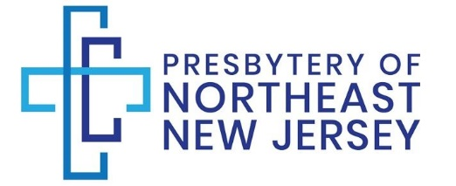

340 W Passaic Street
3rd Floor
Rochelle Park, NJ 07662

Phone (201) 599-1111 Email: office@pnenj.org

2022 Missional/Per Capita Remittance Form

- Church/Individual PIN #

Address Telephone

City, St Email

- Missional Giving $

_____ 1) Presbytery Recommended Formula
30% General Assembly
5% Synod
65% Direct Local Mission (Presbytery)

_____ 2) Session Directed Formula (please specify desired allocation)

- Special Offerings
  - One Great Hour of Sharing (OG999999) $
  - Disaster Relief (Specify) $
  - Christmas Joy (CJ999999) $
  - Hunger (H999999) $
  - Theological Education (TE999999) $______
  - Pentecost Offering (PC999999) $
  - *Peace & Global Witness (PG999999) see reverse $
  - *Peace & Global Witness (Synod) see reverse $
  - *Peace & Global Witness (Presbytery) see reverse $
  - Other (Specify) $

- Directed Missional Giving….Find details /Project Numbers at https://www.presbyterianmission.org/donate/

Project # Project Name

Presbytery/Synod/GA $ Presbytery/Synod/GA $
- Per Capita (year if not 2022) $

- Total Amount of Check Check # $

Please forward this form with your check made payable to: Presbytery of Northeast NJ

Remittance Instructions

The following instructions will enable accurate remittance and disbursement of funds.

- Complete the top portion of the remittance form. It is important to provide the name and telephone number of the person responsible for this remittance in case of questions.

- Basic Missional Support: Enter the amount being remitted toward your mission pledge.

  - Section (1) is for funds to be distributed according to the presbytery recommended formula.
  - Section (2) is for funds to be distributed according to a formula (chosen by the session) which is not what the presbytery recommends. Enter amounts.

- Special Offerings: Enter the amount on the corresponding line being remitted for each special offering. For Emergency Disaster Relief, please name the disaster or provide the account number.
*Peace & Global Witness Offering
25% Congregation
12.5% Synod
12.5% Presbytery
50% General Assembly

- Directed Mission Support:
Find Project Numbers at: https://www.presbyterianmission.org/donate/

- Per Capita: Enter the amount being remitted for your per capita payment.

- Indicate the check number, date and total.

Please make checks payable to: Presbytery of Northeast NJ, and mail with this form to:

Presbytery of the Northeast NJ,

340 W Passaic Street
3rd Floor
Rochelle Park, NJ 07662

Thank You for supporting Presbyterian mission!

